**User Management II**

**To add a user into a group**

**#useradd -g groupname username**

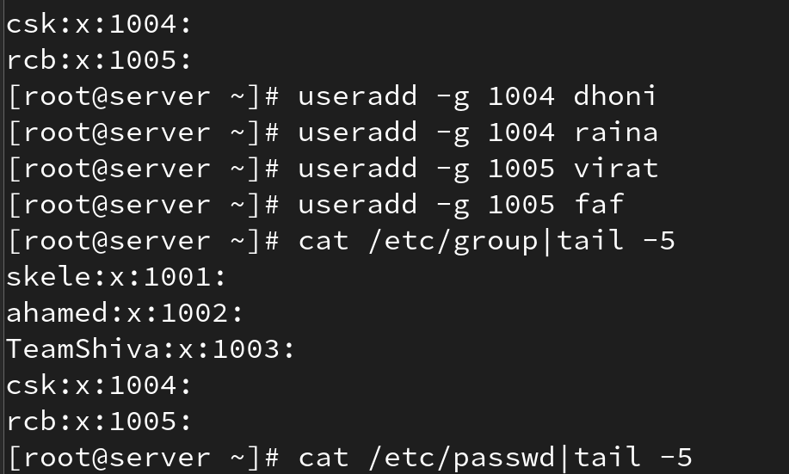

**useradd with predefined parameter**

**useradd -u 2000 -g 3000 -c 'test user' -d /home/test1 -s /bin/sh username**

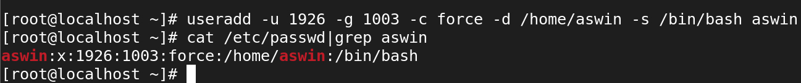

**useradd -M**

**It used to create an user without creating an directory.**

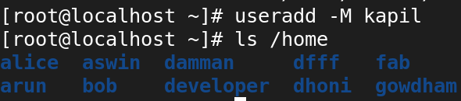

**useradd -e '2021-12-25' username**

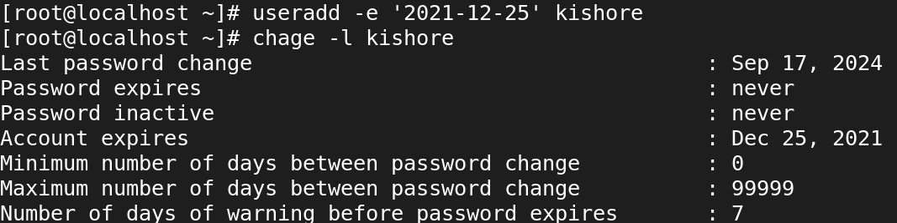

**-l 🡺 loginname**

**-u 🡺 uid**

**-g 🡺 gid**

**-c 🡺 user comment**

**-d 🡺 home directory**

**-s 🡺 shell**

**USERMOD**

**To rename user's account name**

**#usermod -l newname oldname**

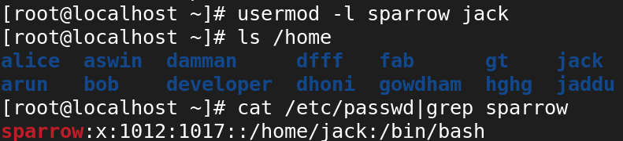

**To change user's UID**

**#usermod -u 1899 username**

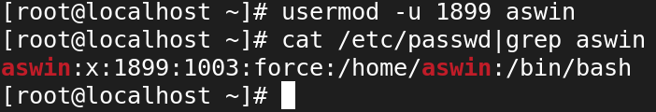

**To change user's GID**

**#usermod -g 1018 username**

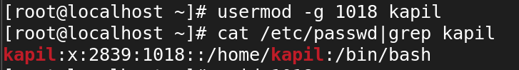

**Changing the User Information**

**usermod -c "Test User" username**

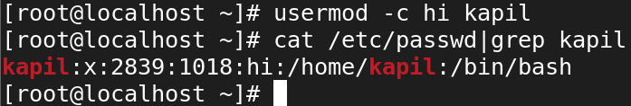

**Setting a User Expiry Date**

**usermod -e "2022-02-21" username**

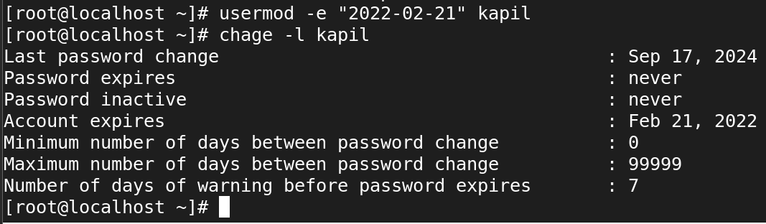

**Locking and Unlocking a User Account**

**Lock**

**usermod -L USER**

· The user's password is "locked" by adding an exclamation mark (!) at the beginning of the password hash in /etc/shadow.

· This prevents the user from authenticating with their password, but the account itself is still there (the user's files and data remain untouched).

**-L: This option locks the user's password, effectively disabling their ability to log in.**

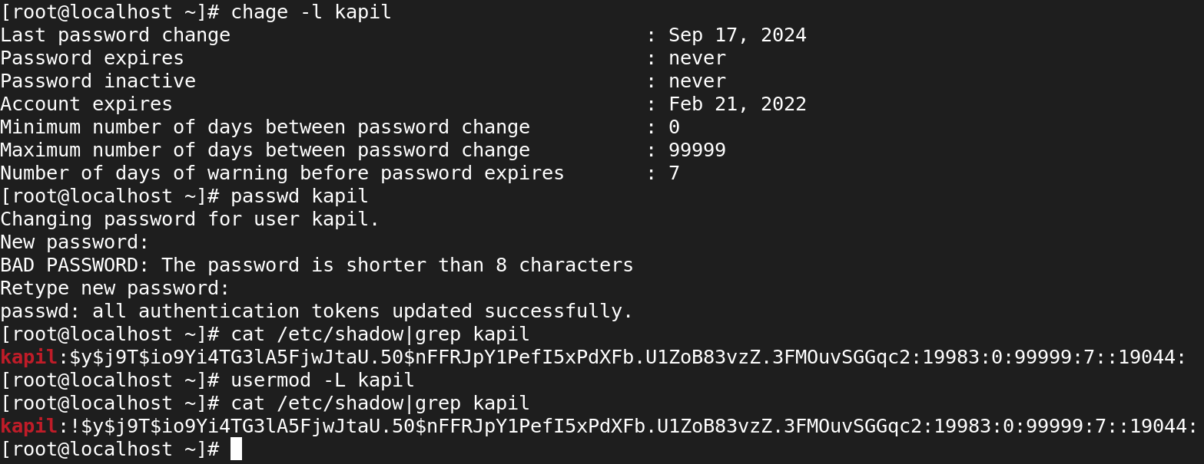

**Unlock**

**usermod -U USER**

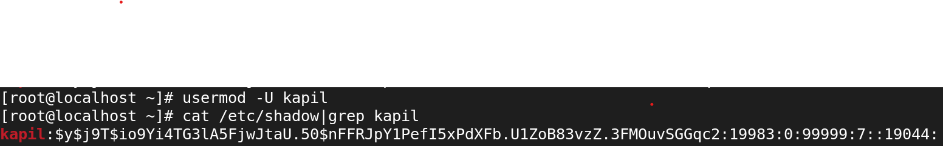

**To check the user's ID or UID with Group ID**

**#id username**

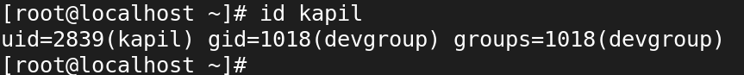

**To verify the user's password information**

**# chage -l username**

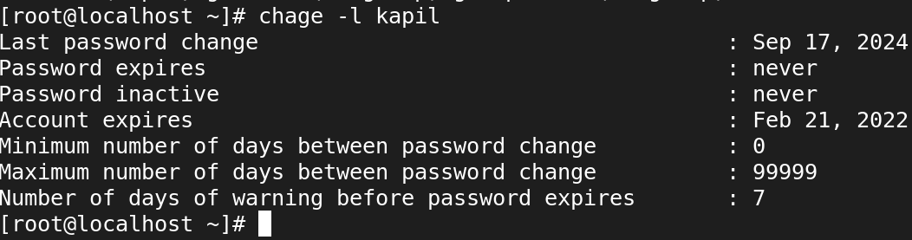

**To change user's minimum password expiry date**

**# chage -m 5 username**

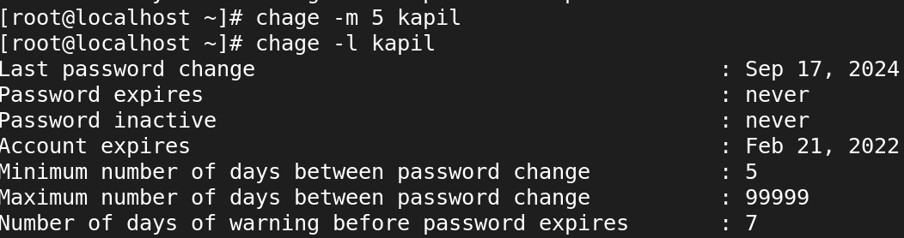

**To change user's maximum password expiry date**

**# chage -M 20 username**

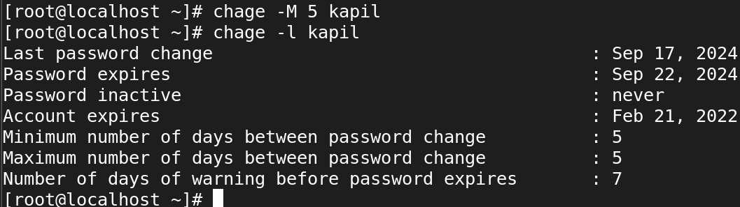

**To change user's minimum password expiry warning date**

**# chage -W 5 username**

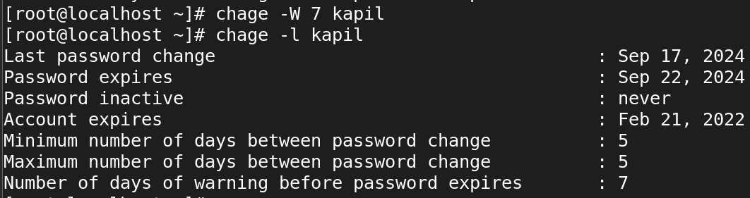

**To change user's password inactive date**

**# chage -I 5 username**

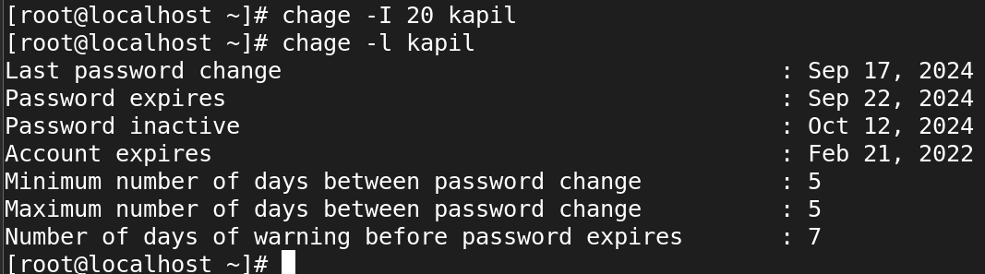

**To change user's password parameters**

**# chage -m 5 -M 20 -W 3 -I 7 username**

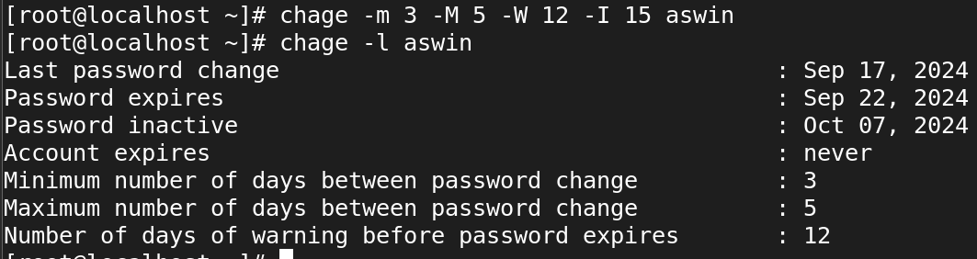

**command -<option>**

**To set the user's account expiry date**

**# chage -E yyyy-mm-dd username**

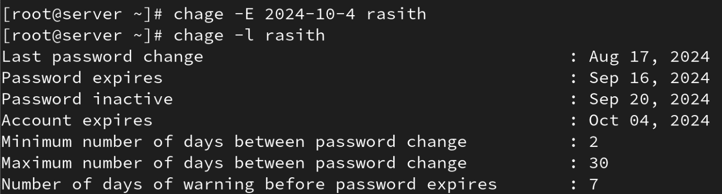

**To see the information of groups**

**# cat /etc/group**

**To create group**

**#groupadd groupname**

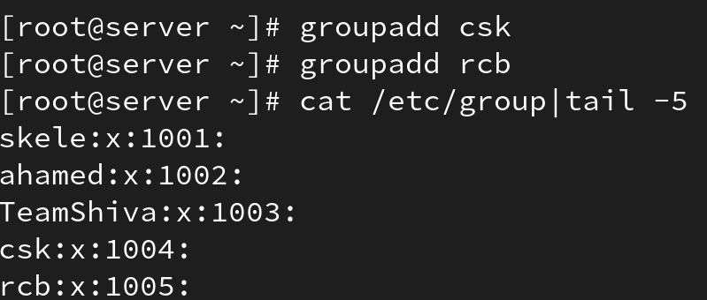

**Add user into a group**

**#gpasswd -a user group (or)**

**#usermod -a -G group user**

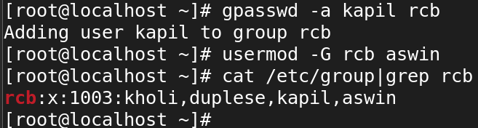

**To change group's GID**

**#groupmod -g GID groupname**

**#groupmod -g 1033 groupname**

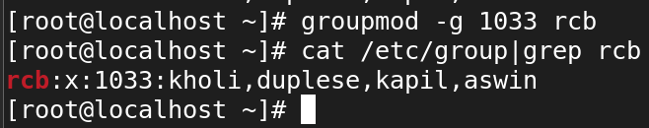

**To rename a group**

**#groupmod -n newgroup oldgroup**

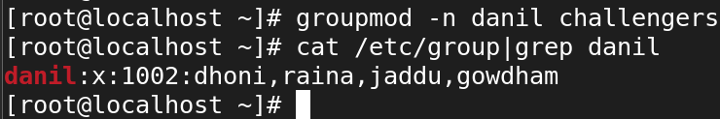

**lock the user password**

**passwd -l username**

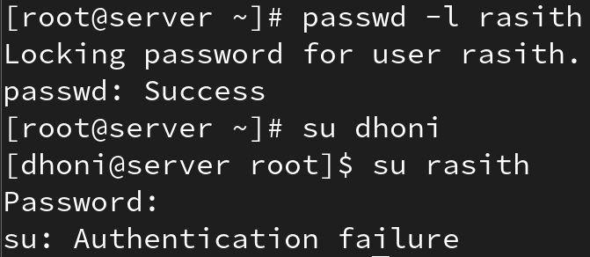

**unlock the userpasword**

**passwd -u username**

